Practical - 1
Practical Title: Project Initiation, Requirement Analysis, Sitemap, Wireframe, and GitHub Setup

Problem Definition: Initiate the semester-long StudentHub portal by identifying the problem scope, user roles, key modules, navigation flow, and minimum 10 pages. Create a sitemap, low-fidelity wireframe, project folder structure, README file, and GitHub repository.

Theory

What is URL and parts of URL?
Answer: URL stands for Uniform Resource Locator. It is the address used to locate a webpage or resource on the Internet.
Main parts of URL:
- Protocol: https://
- Domain: example.com
- Port: :443 (optional)
- Path: /student/index.html
- Query: ?id=10 (optional)
- Fragment: #about (optional)

How does HTML file process in web browser?
Answer: When an HTML file is opened, the browser reads the HTML code and understands its tags and elements. It then loads related CSS, JavaScript, and images. After processing them, the browser renders and displays the webpage on the screen.
Flow:
HTML → Browser reads code → Loads CSS/JS/images → Processes → Displays webpage

3. How will page navigation flow managed among all HTML pages?
Answer: Page navigation is managed using the <a> tag with the href attribute.
Example:
<a href="Home.html">Home</a>
<a href="About.html">About</a>
<a href="Contact.html">Contact</a>
When the user clicks a link, the browser opens the corresponding HTML page.

4. How will GitHub commits be maintained after each practical?
Answer: After completing each practical, the changed files are added and committed to GitHub with a meaningful commit message.
Process:
Complete practical → Add files → Commit → Push to GitHub
Example commit messages:
- Practical 1: Basic HTML
- Practical 2: Page Navigation
- Practical 3: CSS Styling
This helps maintain the project history and track changes after every practical.

References

MDN Web Docs – URL

MDN Web Docs – Creating Links

GitHub Docs – About Git

Implementation/ Output/Result


Evidence of Work (Screenshots)

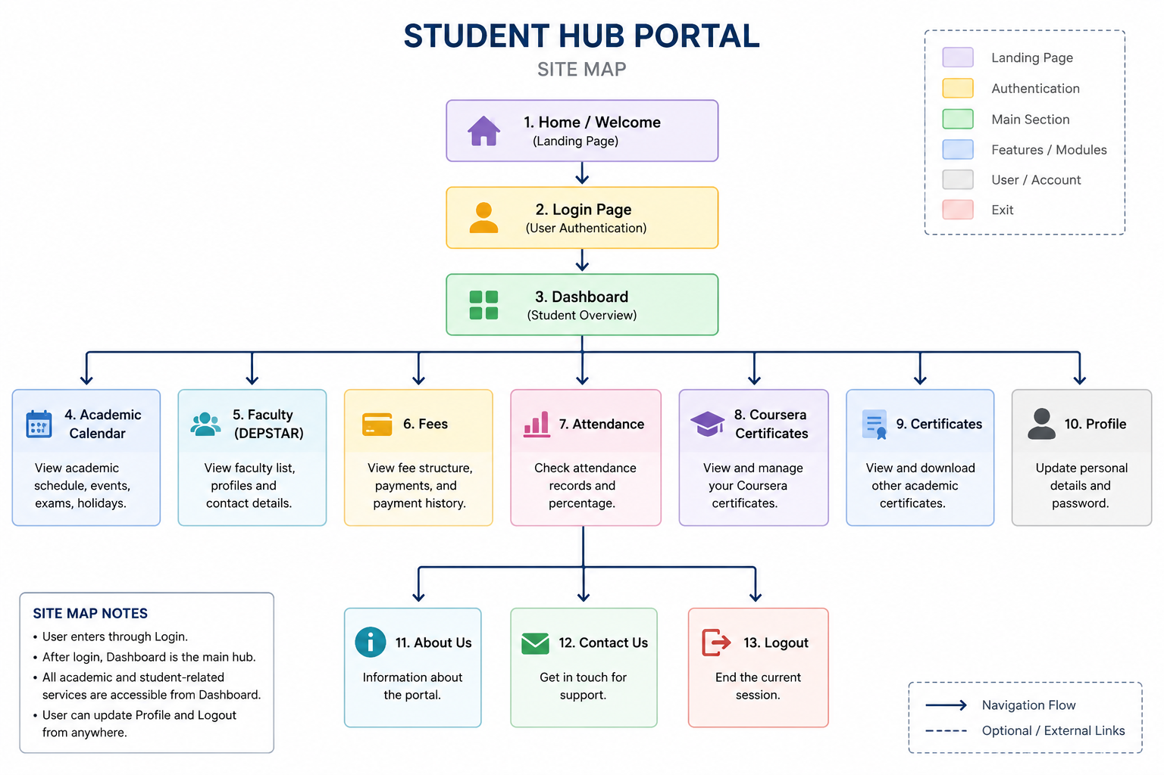

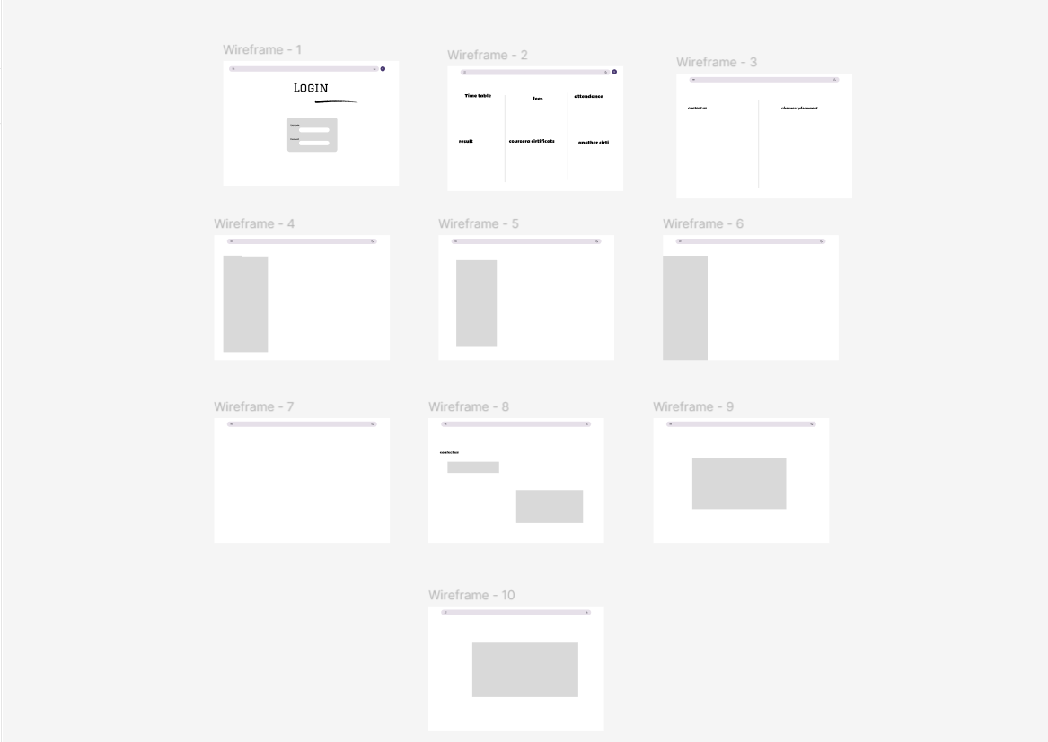

GitHub Repository Link:

https://github.com/NencyNVagadiya/Student-Hub-portal

Challenges Faced:
“I faced difficulty in deciding the project scope, selecting the required pages, designing the navigation flow, and initially setting up the GitHub repository and folder structure.”
1. Page selection – Deciding which 10+ pages were necessary.
2. Navigation flow – Deciding how users should move between pages.
3. Sitemap – Organizing all pages in a proper hierarchy.
4. Wireframe – Deciding where the navbar, sidebar, buttons, and content should be placed.
5. GitHub setup – Understanding repository creation, commits, push, and synchronization.
6. Folder structure – Keeping HTML, CSS, JavaScript, JSON, PHP, and other files organized.

Learning Outcomes:
Students will be able to analyze requirements and prepare a structured project foundation before implementation.

Faculty Remarks:

